Design Document Template
December 10th 2017

OBJECTIVE
To avoid user feeling odd to redirect login page while they click on search bar and add preview function for each track in playlist.

BACKGROUND
The prominent flaw I found from Jammming is the odd feeling that it redirect me to a login page after I clicked the search bar. If visitor use this app, they expect to search a song directly, but a login box will prompt to interrupt their searching. Therefore, an undesirable user experience will happen, and when a user return to use the app, he will had this bad experience over and over again. Hence, I propose a login page with a transparent background over the search bar, and I am inspired by the Pinterest website.
Moreover, I would suggest a preview function for user to listen a short part of a song, maybe 10 seconds, so this could prevent user to add a song which is same name with the one they search.

TECHNICAL DESIGN

A login Div cover the front page
As replacing the redirect Spotify login page with a login page cover the front search page, there are some steps to implement. To begin with, I will put a div element, which contain the Spotify login part, in the render part of app.js. This Spotify Login div should be connected with Spotify.js, so a component of Spotify may be put in this div. On top of that, this new login div will cover the front page with a trasparent background, this will be achieved by css z-index to put this div over the front page (as shown in the image below). I propose a transparent background for the Spotify Login div, because user could recognize that after they login they could immediately to search the songs. Moreover, after the user login, the login page may disappear promptly or fade out with a css animation.

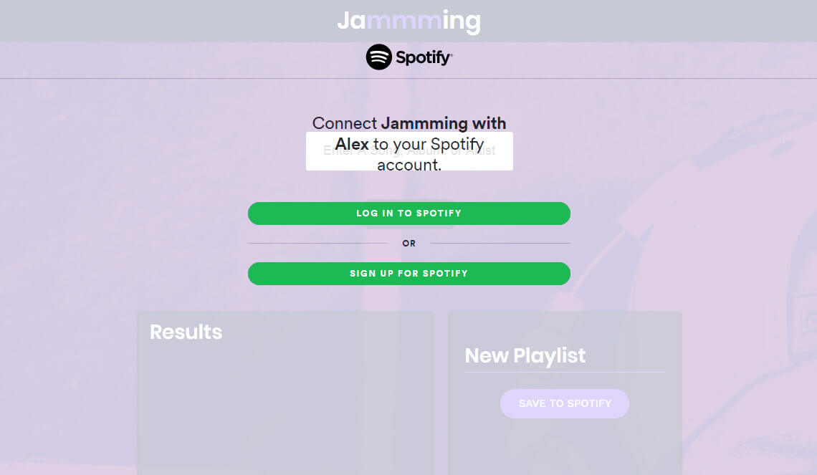
Preview function for each track in TrackList of SearchResults
In my own case, there could be same name for many songs after I searched a song, so a short preview of a song can help user to ensure a song before adding to a song list. This short preview function could be achieved by adding a mouse over function to a track in the TrackList.js, then the mouse over could trigger to play a 10 second preview of that song in the search result.

CAVEATS
As the login Div I proposed is inspired by Pinterest that when a user scroll down the page awhile, a prompt of login will exist, so I think my suggestion is viable. However, a transparent background may induce unclear at the first glance. There, we could put the Spotify login page as our front page, a Jammming title could be added at the top of the page to prompt what this app is.
For the preivew function of track in search result, trigger of this function may be subtle by a mouse over. Therefore, a preview button could be added next of each track in search result, this preview button could be added in the render part of Track.js.

